A QUANTITATIVE ANALYSIS OF CANDIDATES IN THE 2019 LOK SABHA ELECTIONS

INTORDUCTION:

The nominations for all phases of the lok sabha election have been submitted. We examine highlights from data on candidates who are participating in the ongoing elections. There are 8,039 candidates contesting for 542 parliamentary constituency seats.

EMPATHY: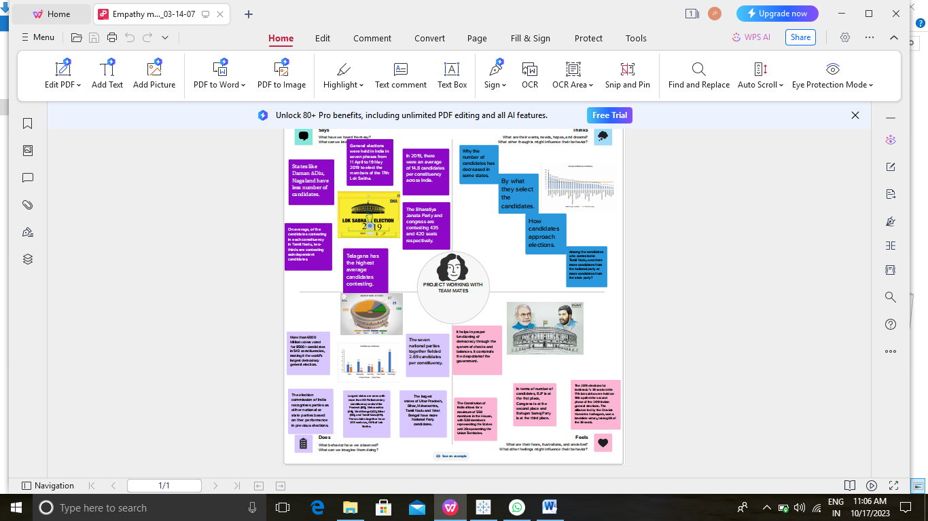

BRAINSTORM MAP: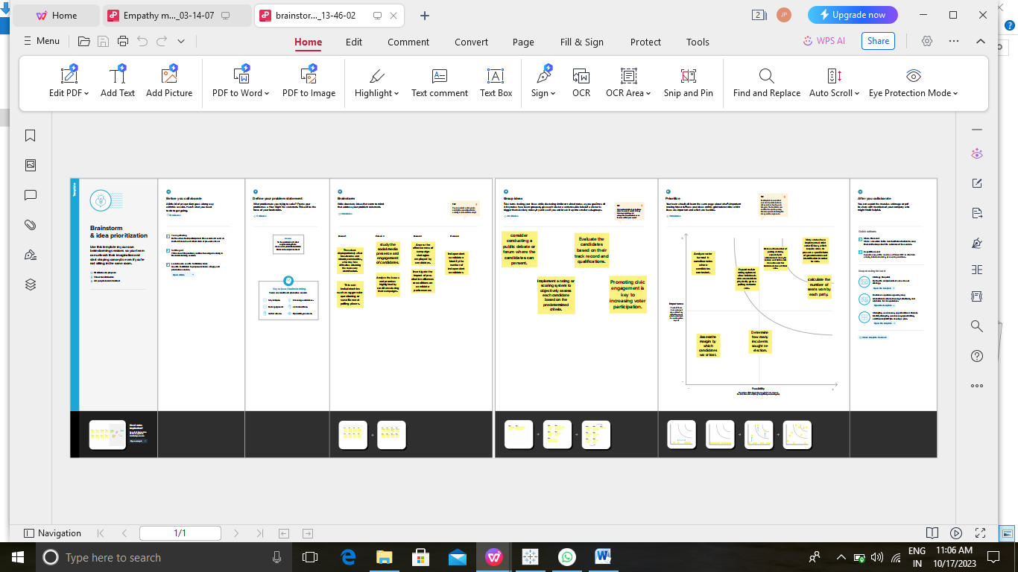

TABLEAU TEXT BOOK

1. We have take a dateset and we analysis the date by using tableau.

2. Tabealu is the most powerful, secure, and Flexible end-to-end abaalytics platform for your data. Elevate people with the powr of data.

3. Designed for the individidual, but scaled for the enterprise, Tableau is the only business intelligence platform that turns your data into isights that drive action.

DASHBOARD

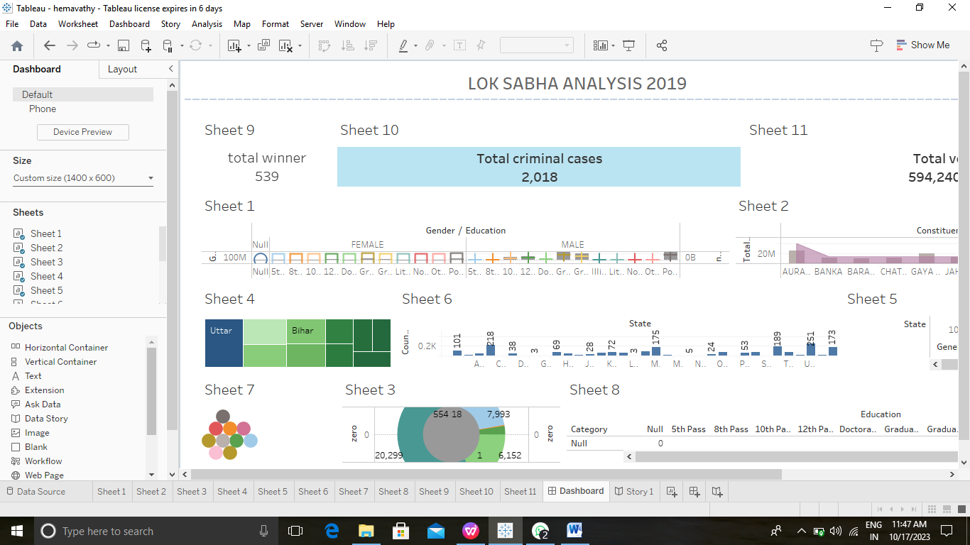

STORY: